To find out what the difference is between major, minor and dominant you should read the guitar music theory tutorial.
Here's the list of basic guitar chords:
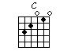 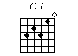
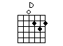 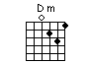
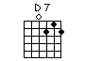
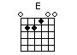 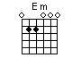
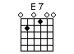
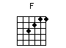
The F chord is a bit of a special case: the top 2 notes are fretted with one finger (the index finger).
This is one of the hardest chords to play for the beginner, but you'll soon get the hang of it (if you practice enough).
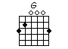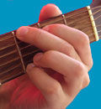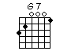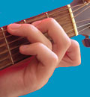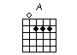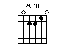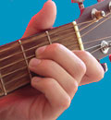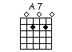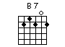
After you played these basic guitar chords some times I suggest you do the following:
- Print out this free printable guitar chord chart. That page also explains the difficulties you might encounter and what to do with your right hand.
- Go to the next page and start practicing some guitar songs that only make use of the beginner guitar chords learned on this page.
Next Page: Basic Guitar Song Chords

